Essential Being Massage
Name______________________________________ Date__________________________
Date of birth_________________________________ Phone_______________________
Address______________________________________ City/State____________________
Email__________________________________________ Occupation_________________
How did you hear about Essential Being Massage?_________________________________
Are you pregnant? ___________ If so, how many weeks are you?__________________

Please review this list and check those that conditions that have affected your health either recently or in the past. Place a check mark next to the condition.

___Arthritis ___Hepatitis (A,B,C, other) / Blood disorder
___Depression, panic disorder ___Chronic Pain
___High/low blood pressure ___Bruise Easily
___Diabetes ___Skin condition
___Back problems ___Stroke
___Blood clots ___Whiplash
___Headaches /Migraines ___Fibromyalgia
___Insomnia ___Heart condition
___Broken bones

Please mark an X on the areas of discomfort below
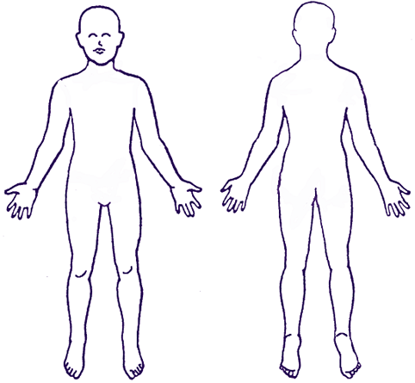

- I understand that although massage can be very therapeutic, relaxing and reduce muscular tension, it is not a substitute for medical examination, diagnosis and/or treatment.
- I understand that it is my responsibility to communicate any physical or emotional discomfort during the massage session. This includes room temperature, music, and depth of pressure.
- I understand that this is a therapeutic massage and any sexual remarks or advances will immediately terminate the session and I am liable for payment in full for the scheduled session time.
- Payment is due at the time of service.
- There is a minimum of a 24 hour cancellation notice required. If I fail to cancel within the 24 hour period, or fail to no show, I understand that I will still be liable to pay for the booked session amount.
- If I show up late, the length of the session will only be for the allotted time of the original session.
- Proper draping standards will always be observed.
- Prepaid sessions expire 2 years after they are bought.
- I confirm I have answered all questions pertaining to medical questions truthfully.

Signature_________________________________________ Date___________________

